DC Brushless Water Pump
- Product Parameter
Model  Character |  |  | HM3002-2
Working voltage range |  |  | 5VDC-24VDC
Optional rated power |  |  | 0.3~4W
Optional static water head |  |  | 0.5~2 meters
Optional static flow rate |  |  | 1~3.5L/min
Lifespan |  |  | Continuous operation under normal working surrounding＞20000H
Working Environment |  |  | PH value: PH5-10(weak acid and weak base),workable in water, submersible pump
Max noise |  |  | Under normal working condition,(1meter over the test instrument)＜35dB
Other optional special functions |  |  | Water shortage protection, over-voltage protection, over-current protection, blocking protection, 0-5V speed control, PWM speed control, FG signal feedback, UV LED disinfection lamp, etc.
Max working temperature |  |  | Under room temperature surroundings, fluid medium temperature≤70℃
Application |  |  | Water dispenser, humidifier, pet drinking water dispenser, small fountain, aquarium, solar water circulation system, soil-less cultivation, hydroponics, decorative potted plants, foot bath basin, small medical equipment, crafts, etc.
Color |  |  | White/ Black (Can be customized according to customer`s requirement)
Outlet direction |  |  | Can be adjustable at any angle
Dimension |  |  |  | IP grade | Inlet |  | Outlet |  | Remarks
Length（mm） | Width（mm） | Height（mm） |  | IP grade | OD（mm） | ID（mm） | OD（mm） | ID（mm）
39.0 | 37.0 | 44.5 |  | IP68 | ------- | ------- | 8.5 | 5.5
- Outside View
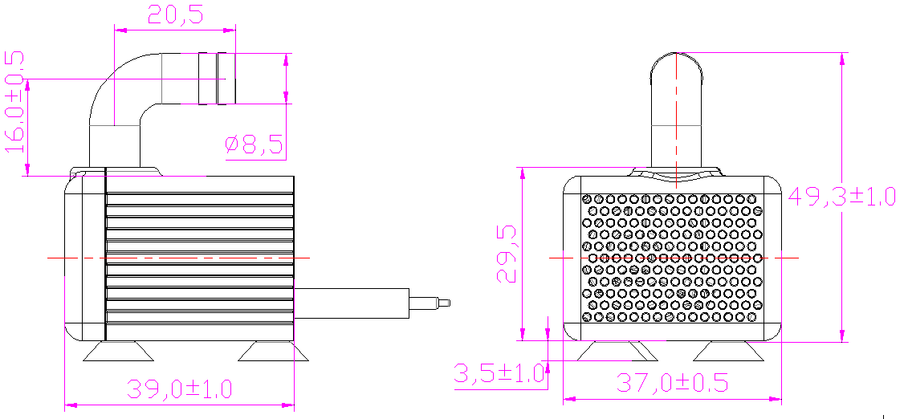
- Curve Graph
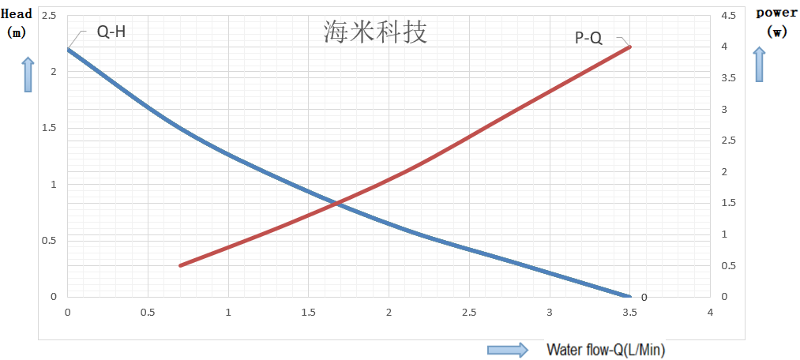

Remarks: The graph is just for your reference, the final one comes with the customer required specifications.
- Photo for you reference
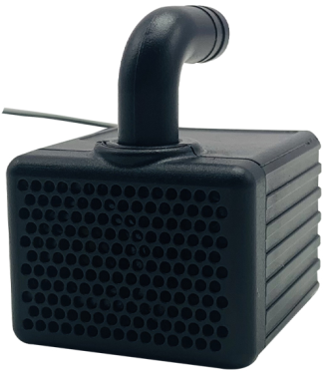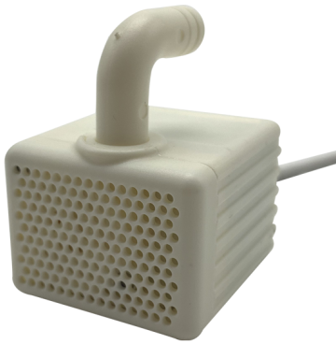
Two colors for choosing

