DC Brushless Water Pump
- Product Parameter
Model  Character |  |  | HM3207-1
Rated working voltage |  |  | 12VDC
working voltage range |  |  | 10VDC-14VDC
Rated power |  |  | 4.8W
Static water head |  |  | 3 meters
Static flow rate |  |  | 240 L/H
Lifespan |  |  | Continuous operation under normal working surrounding＞20000H
Working Environment |  |  | PH value: PH5-10(weak acid and weak base), workable both on land and in water.
Max noise |  |  | Under normal working condition,(1meter over the test instrument)＜35dB
Max working temperature |  |  | Under room temperature surroundings, fluid medium temperature≤70℃
Application |  |  | Water circulation of humidifier, air conditioner and fans, hydroponics, smart garden herbs, garden fountain, aquarium, water tank, fish pond, solar water circulation, water circulation of home appliance, etc.
Color |  |  | Black (Can be customized according to customer`s requirement)
Outlet direction |  |  | Can be adjustable at any angle
Dimension |  |  |  | IP grade | Inlet |  | Outlet |  | Remarks
Length  （mm） | Width（mm） | Height（mm） |  | IP grade | OD（mm） | ID（mm） | OD（mm） | ID（mm） | Inlet and outlet have anti slip strip
54.4 | 52.0 | 40.8 |  | IP68 | 8.5 | 6.0 | 8.5 | 6.0 | Inlet and outlet have anti slip strip
- Outside View
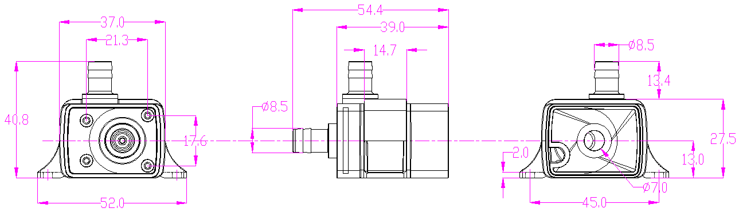
- Curve Graph
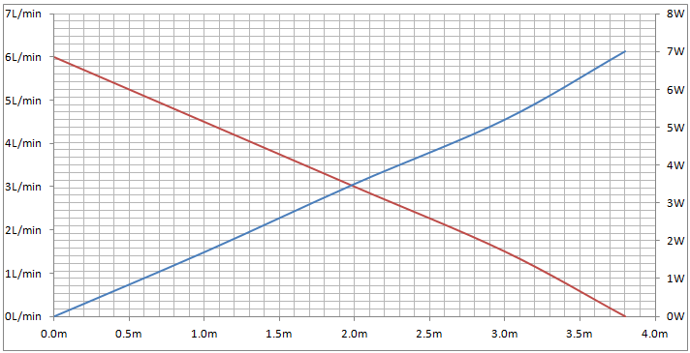
Remarks: The graph is just for your reference, the final one comes with the customer required specifications.
- Photo for your reference
