DC Brushless Water Pump
- Product Parameter
Model  Character |  |  | HM2507-1
Working voltage range |  |  | 5VDC-24VDC
Optional rated power |  |  | 0.5~4W
Optional static water head |  |  | 0.5~2.5 meters
Optional static flow rate |  |  | 0.5 ~ 3L/min
Lifespan |  |  | Continuous operation under normal working surrounding＞20000H
Working Environment |  |  | PH value: PH5-10(weak acid and weak base), workable in water and on land.
Max noise |  |  | Under normal working condition,(1meter over the test instrument)＜35dB
Other optional special functions |  |  | Water shortage protection, over-voltage protection, over-current protection, blocking protection, 0-5V speed control, PWM speed control, FG signal feedback, etc.
Max working temperature |  |  | Under room temperature surroundings, fluid medium temperature≤70℃
Application |  |  | Drainage function for small appliances,water dispenser, humidifier, pet drinking water dispenser, small fountain, aquarium, solar water circulation system, soilless cultivation, hydropnics, Decorative potted plants,foot bath basin, small medical equipment, crafts, etc.
Color |  |  | White (Can be customized according to customer`s requirement)
Outlet direction |  |  | Can be adjustable at any angle
Dimension |  |  |  | IP grade | Inlet |  | Outlet |  | Remarks
Length（mm） | Width（mm） | Height（mm） |  | IP grade | OD（mm） | ID（mm） | OD（mm） | ID（mm） | Outlet have anti-slip strip
45.0 | 25.5 | 47.7 |  | IP68 | ------- | ------- | 7.2 | 4.8 | Outlet have anti-slip strip
- Outside View
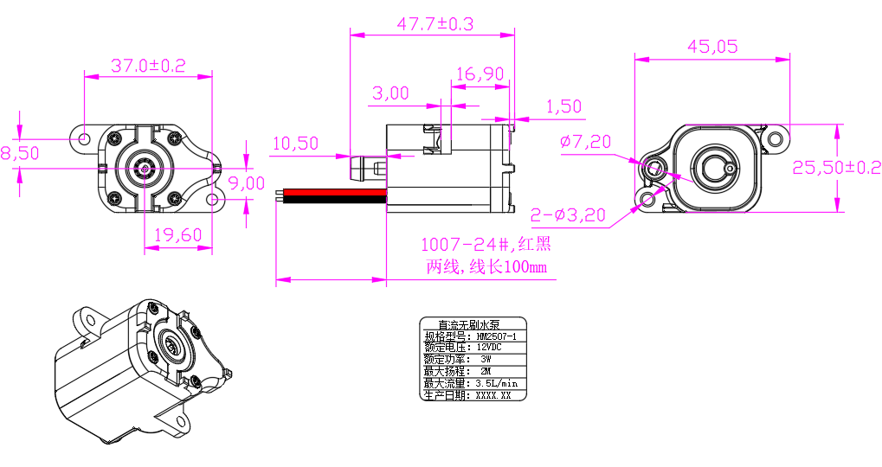
- Curve Graph
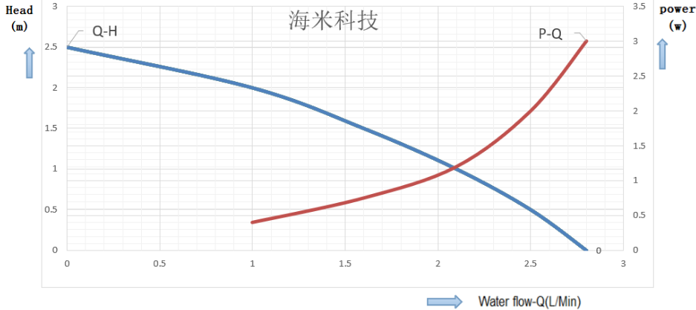

Remarks: The graph is just for your reference, the final one comes with the customer required specifications.
- Photo for you reference
