DC Brushless Water Pump
- Product Parameter
Model  Character |  |  | HM6001-1( Three phase pump)
Working voltage range |  |  | 12VDC-48VDC
Rated power |  |  | 12~80 W
Static water head |  |  | 2~15 meters
Static flow rate |  |  | 10~ 30 L/min
Lifespan |  |  | Continuous operation under normal working surrounding＞20000H
Working Environment |  |  | PH value: PH5-10(weak acid and weak base), workable both on land and in water.
Max noise |  |  | Under normal working condition,(1meter over the test instrument)＜45dB
Max working temperature |  |  | Under room temperature surroundings, fluid medium temperature≤75℃/100℃
Other optional special functions |  |  | Water shortage protection, over-voltage protection, over-current protection, blocking protection, 0-5V speed control, PWM speed control, FG signal feedback, etc.
Application |  |  | (EV)Water circulation cooling systems, motorcycle engines, automotive water coolants, solar water circulation systems, solar water heating systems, solar pool heating systems, water heater pressure boosters, high-rise building water pressure boosters, sewage systems, lathe washing systems, car wash systems, household appliance water circulation systems, agriculture irrigation, fountain, aquarium, water tank, fish pond, crafts, etc.
Color |  |  | Black (Can be customized according to customer’s requirement)
Outlet direction |  |  | Can be adjustable at any angle
Dimension |  |  |  | IP grade | Inlet |  | Outlet |  | Remarks
Length  （mm） | Width（mm） | Height（mm） |  | IP grade | OD（mm） | ID（mm） | OD（mm） | ID（mm） | Inlet and outlet have threads.
95.0 | 60.0 | 110.0 |  | IP68 | G1/2 standard thread | 15.0 | G1/2 standard thread | 14.0 | Inlet and outlet have threads.
- Outside View
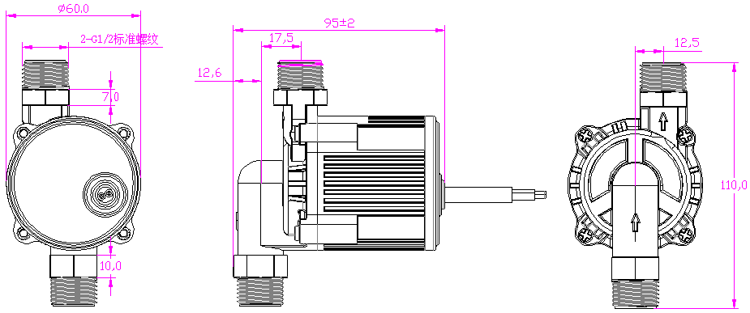
- Curve Graph
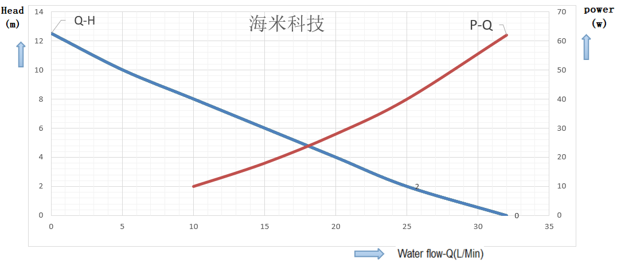

Remarks: The graph is just for your reference, the final one comes with the customer required specifications.
- Photo for your reference
