DC Brushless Water Pump
- Product Parameter
Model  Character |  |  | HM651205-4 ( Three phase pump)
Working voltage range |  |  | 9VDC-13.5VDC
Rated voltage |  |  | 12VDC
Rated power |  |  | ≤5W
Max static water head |  |  | 1.6±10% Meters
Static flow rate |  |  | ＞550mL/min@1.2m
Lifespan |  |  | Continuous operation under normal working surrounding＞20000H
Working Environment |  |  | PH value: PH5-10(weak acid and weak base), workable both in water and on land.
Max noise |  |  | Under normal working condition,(1meter over the test instrument)＜30dB
Max working temperature |  |  | Under room temperature surroundings, fluid medium temperature≤70℃
Other optional special functions |  |  | Water shortage protection, over-voltage protection, over-current protection, blocking protection, 0-5V speed control, PWM speed control, FG signal feedback, etc.
Application |  |  | Air conditioner drainage system, portable air conditioner drainage system, small electrical appliance drainage system, potted plant decoration, hydroponics, humidifier, small fountain, aquarium, small medical equipment, handicrafts, etc.
Color |  |  | Black (Can be customized according to customer’s requirement)
Outlet direction |  |  | Can be adjustable at any angle
Dimension |  |  |  | IP grade | Inlet |  | Outlet |  | Remarks
Length  （mm） | Width（mm） | Height（mm） |  | IP grade | OD（mm） | ID（mm） | OD（mm） | ID（mm） | Outlet has anti-slip strip.
98.0 | 82.0 | 76.0 |  | IP67 | 20.0 | 10.5 | 16.0 | 9.0 | Outlet has anti-slip strip.
- Outside View
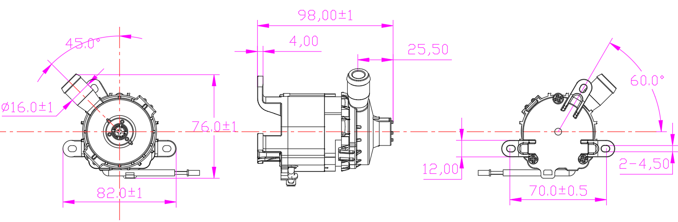
- Curve Graph
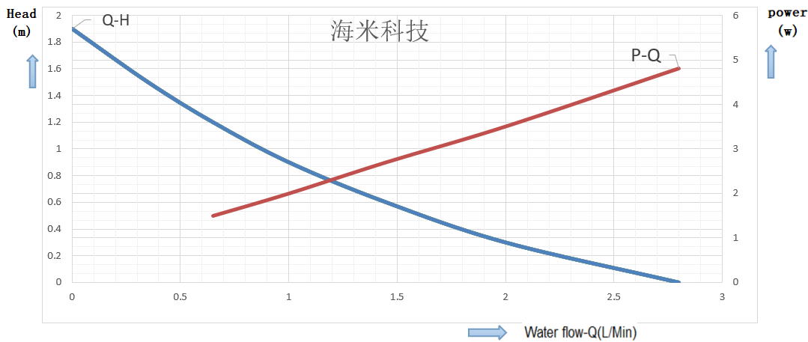

Remarks: The graph is just for your reference, the final one comes with the customer required specifications.
- Photo for your reference
