DC Brushless Water Pump
- Product Parameter
Model  Character |  |  | HM90120W-1( Three phase pump)
Working voltage range |  |  | 10VDC-26VDC
Optional rated voltage |  |  | 6VDC/12VDC/24VDC (Other rated voltage can be supplied)
Rated power |  |  | 40~120 W
Static water head |  |  | 1~6 meters
Static flow rate |  |  | 10~ 60 L/min
Lifespan |  |  | Continuous operation under normal working surrounding＞20000H
Working Environment |  |  | PH value: PH5-10(weak acid and weak base), workable in water, submersible pump.
Max noise |  |  | Under normal working condition,(1meter over the test instrument)＜45dB
Max working temperature |  |  | Under room temperature surroundings, fluid medium temperature≤70℃
Other optional special functions |  |  | Water shortage protection, over-voltage protection, over-current protection, blocking protection, 0-5V speed control, PWM speed control, FG signal feedback, etc.
Application |  |  | Sewage systems, portable handheld water stick, solar-powered hot water circulation systems, solar pool heating systems, household appliance water circulation systems, fountains, aquariums, crafts, etc.
Color |  |  | Black (Can be customized according to customer’s requirement)
Outlet direction |  |  | Can be adjustable at any angle
Dimension |  |  |  | IP grade | Inlet |  | Outlet |  | Remarks
Length  （mm） | Width（mm） | Height（mm） |  | IP grade | OD（mm） | ID（mm） | OD（mm） | ID（mm） | Outlet has threads.
140.0 | 120.0 | -- |  | IP68 | 120 | -- | 50 | G1″ threads | Outlet has threads.
- Outside View
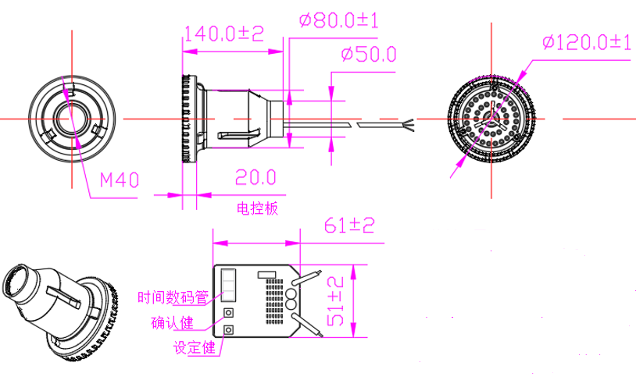
- Curve Graph
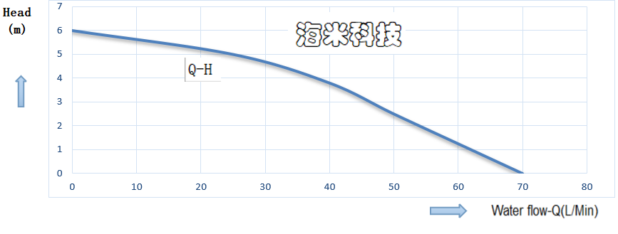
Remarks: The graph is just for your reference, the final one comes with the customer required specifications.
- Photo for your reference
