DC Brushless Water Pump
- Product Parameter
Model  Character |  |  | HM6002-1( Three phase pump)
Working voltage range |  |  | 12VDC-48VDC
Rated power |  |  | 12~80 W
Static water head |  |  | 2~15 meters
Static flow rate |  |  | 10~ 30 L/min
Lifespan |  |  | Continuous operation under normal working surrounding＞20000H
Working Environment |  |  | PH value: PH5-10(weak acid and weak base), workable both on land and in water.
Max noise |  |  | Under normal working condition,(1meter over the test instrument)＜45dB
Max working temperature |  |  | Under room temperature surroundings, fluid medium temperature≤75℃/100℃
Other optional special functions |  |  | Water shortage protection, over-voltage protection, over-current protection, blocking protection, 0-5V speed control, PWM speed control, FG signal feedback, etc.
Application |  |  | Solar water circulation systems, solar water heating systems, solar pool heating systems, water heater pressure boosters, high-rise building water pressure boosters, sewage systems, lathe washing systems, (EV)Water circulation cooling systems, car wash systems, household appliance water circulation systems, agriculture irrigation, fountain, aquarium, water tank, fish pond, crafts, etc.
Color |  |  | Black (Can be customized according to customer’s requirement)
Outlet direction |  |  | Can be adjustable at any angle
Dimension |  |  |  | IP grade | Inlet |  | Outlet |  | Remarks
Length  （mm） | Width（mm） | Height（mm） |  | IP grade | OD（mm） | ID（mm） | OD（mm） | ID（mm） | Inlet and outlet have anti-slip strips.
98.0 | 73.2 | 87.0 |  | IP68 | 30.0 | 20.0 | 20.0 | 12.3 | Inlet and outlet have anti-slip strips.
- Outside View
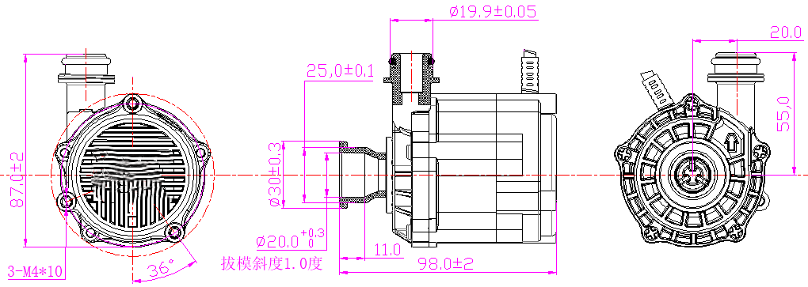
- Curve Graph
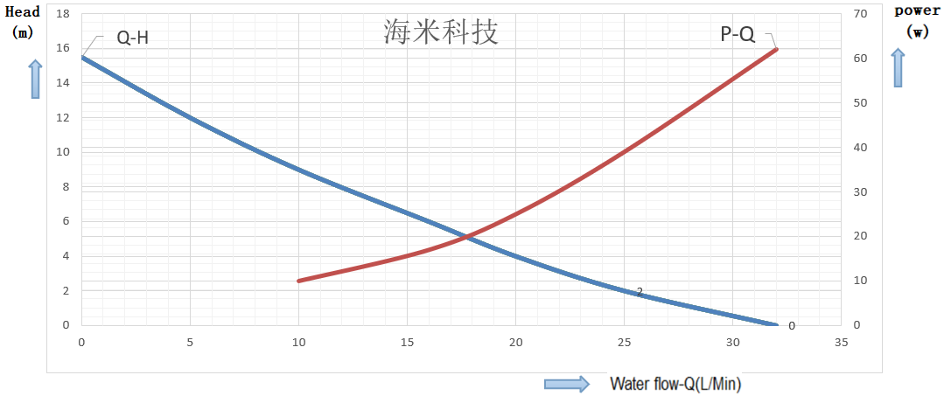

Remarks: The graph is just for your reference, the final one comes with the customer required specifications.
- Photo for your reference
