DC Brushless Water Pump
- Product Parameter
Model  Character |  |  | HM4505-1 ( Three phase pump)
Working voltage range |  |  | 6VDC-24VDC
Rated power |  |  | 10~60 W
Static water head range |  |  | 2~13 meters
Static flow rate range |  |  | 5~ 20 L/min
Lifespan |  |  | Continuous operation under normal working surrounding＞20000H
Working Environment |  |  | PH value: PH5-10(weak acid and weak base), workable both on land and in water.
Max noise |  |  | Under normal working condition,(1meter over the test instrument)＜40dB
Other optional special functions |  |  | Water shortage protection, over-voltage protection, over-current protection, blocking protection, 0-5V speed control, PWM speed control, FG signal feedback, etc.
Max working temperature |  |  | Under room temperature surroundings, fluid medium temperature≤75℃
Application |  |  | Solar/Gas/Electric water heater, bathtub, bathroom intelligent smart electric toilet, Kitchen equipment, swimming pool spa heating system, medical equipment, beauty equipment, mobile bath machine, mobile air conditioner, tab water booster, solar fountain, aquarium, water tank, fish pond, solar water circulation, water circulation of home appliance, crafts, etc.
Color |  |  | Black (Can be customized according to customer`s requirement)
Outlet direction |  |  | Can be adjustable at any angle
Dimension |  |  |  | IP grade | Inlet |  | Outlet |  | Remarks
Length  （mm） | Width（mm） | Height（mm） |  | IP grade | OD（mm） | ID（mm） | OD（mm） | ID（mm） | Inlet and outlet have threads.
94.0 | 46.5 | 83.5 |  | IP66 | G1/2 standard thread | 14.0 | G1/2 standard thread | 14.0 | Inlet and outlet have threads.
- Outside View
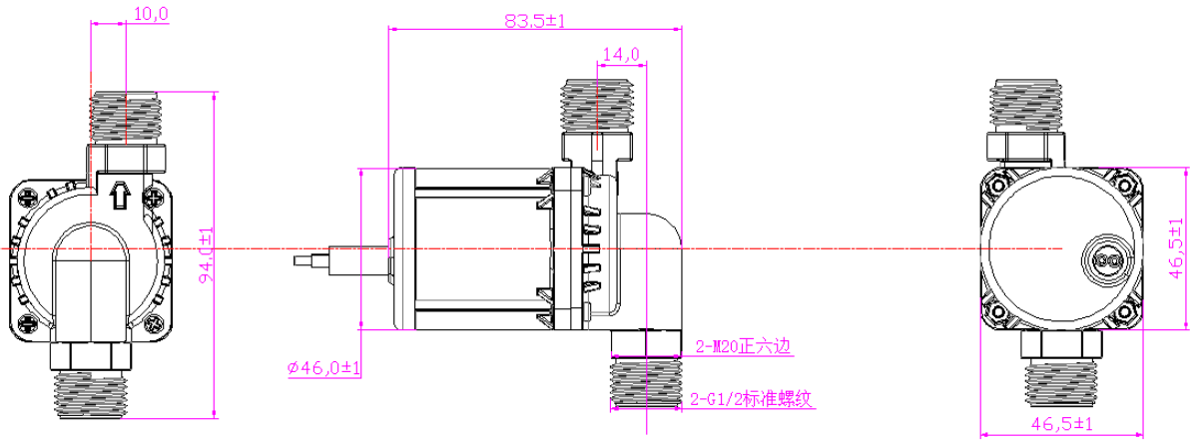
- Curve Graph
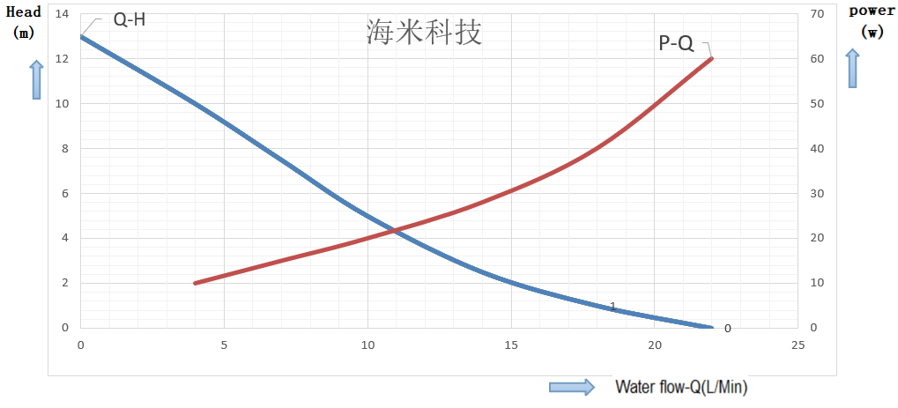

Remarks: The graph is just for your reference, the final one comes with the customer required specifications.
- Photo for your reference
